FUNCTION DETAILS: 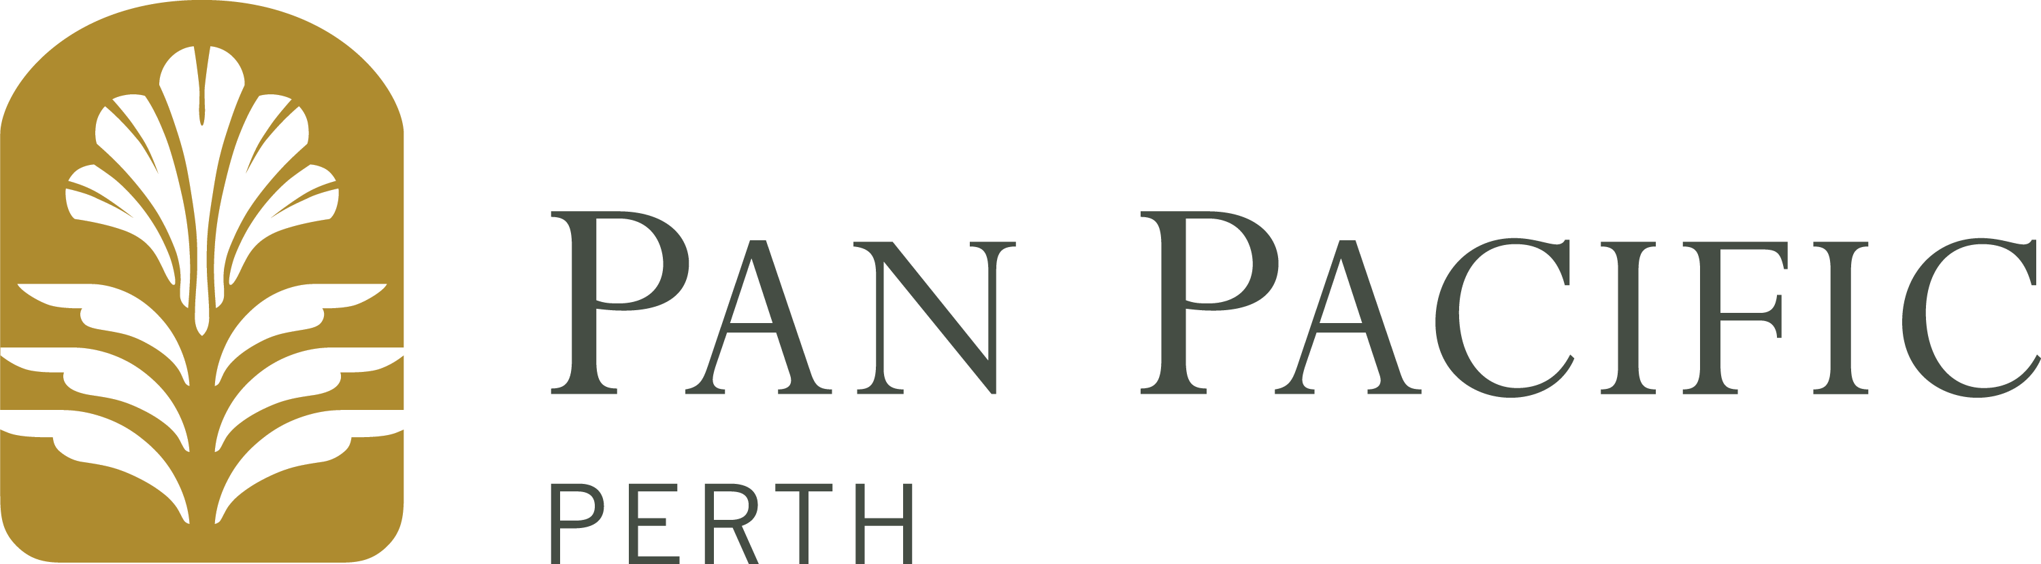
Event Name: NATSIEH 2019
Event Date: 16-19 September 2019
Function Room: Mount Newman
Company Contact on day: Adam Druce
Company Contact Phone on day: 0412049760
Item Description: POSTER PRESENTATION
To: DELIVERY DETAILS

Attention Banquets:

PAN PACIFIC PERTH
LOADING DOCK
HILL STREET
PERTH WA 6000
BOX of

FROM: SENDER DETAILS
Company Name:
Address:
Contact Person:
Telephone:
Mobile:

Are you an Exhibitor/Sponsor at this Event? NO
Does this contain Exhibition Booth Material? NO
If so, please provide your Exhibition Booth #

Delivery of goods to Pan Pacific Perth:
Goods can be delivered to Pan Pacific Perth between 0600-1530 hours Monday to Friday (excluding public holidays). Items should only be delivered up to 3 working days prior to the event commencement.

Pick-Up of goods from Pan Pacific Perth:
Goods can be collected from Pan Pacific Perth between 0600-1530 hours Monday to Friday (excluding public holidays). If goods are being collected by a courier, please ensure all items have a valid consignment note attached.
Instructions:
Pan Pacific Perth will not accept responsibility for the collection of goods (including consignment notes) and for any items delivered or left for collection outside the times advised above. Leftover items not collected within 5 days of the event, will be disposed of.

